## **REACT**

**Hands-on 1:**

Create a React Application named “cricketapp” with the given components.

**CODE:**

**ListofPlayers.java**

import React from 'react';

const players = [

  { name: "Virat", score: 80 },

  { name: "Rohit", score: 65 },

  { name: "Dhoni", score: 90 },

  { name: "Kohli", score: 60 },

  { name: "Jadeja", score: 50 },

  { name: "Hardik", score: 85 },

  { name: "Rahul", score: 45 },

  { name: "Gill", score: 75 },

  { name: "Pant", score: 35 },

  { name: "Ashwin", score: 95 },

  { name: "Bumrah", score: 55 }

];

const ListofPlayers = () => {

  const filtered = players.filter(p => p.score < 70);

  return (

    <div>

      <h2>All Players</h2>

      {players.map((player, i) => (

        <p key={i}>{player.name} - {player.score}</p>

      ))}

      <h2>Filtered Players (score &lt; 70)</h2>

      {filtered.map((player, i) => (

        <p key={i}>{player.name} - {player.score}</p>

      ))}

    </div>

  );

};

export default ListofPlayers;

IndianPlayers.java

import React from 'react';

const T20players = ["Virat", "Rohit", "Hardik"];

const RanjiPlayers = ["Pujara", "Rahane", "Shreyas"];

const IndianPlayers = () => {

  const merged = [...T20players, ...RanjiPlayers];

  const [odd, even] = [

    merged.filter((_, i) => i % 2 !== 0),

    merged.filter((_, i) => i % 2 === 0)

  ];

  return (

    <div>

      <h2>Merged Players</h2>

      {merged.map((p, i) => <p key={i}>{p}</p>)}

      <h2>Even Team</h2>

      {even.map((p, i) => <p key={i}>{p}</p>)}

      <h2>Odd Team</h2>

      {odd.map((p, i) => <p key={i}>{p}</p>)}

    </div>

  );

};

export default IndianPlayers;

**OUTPUT:**

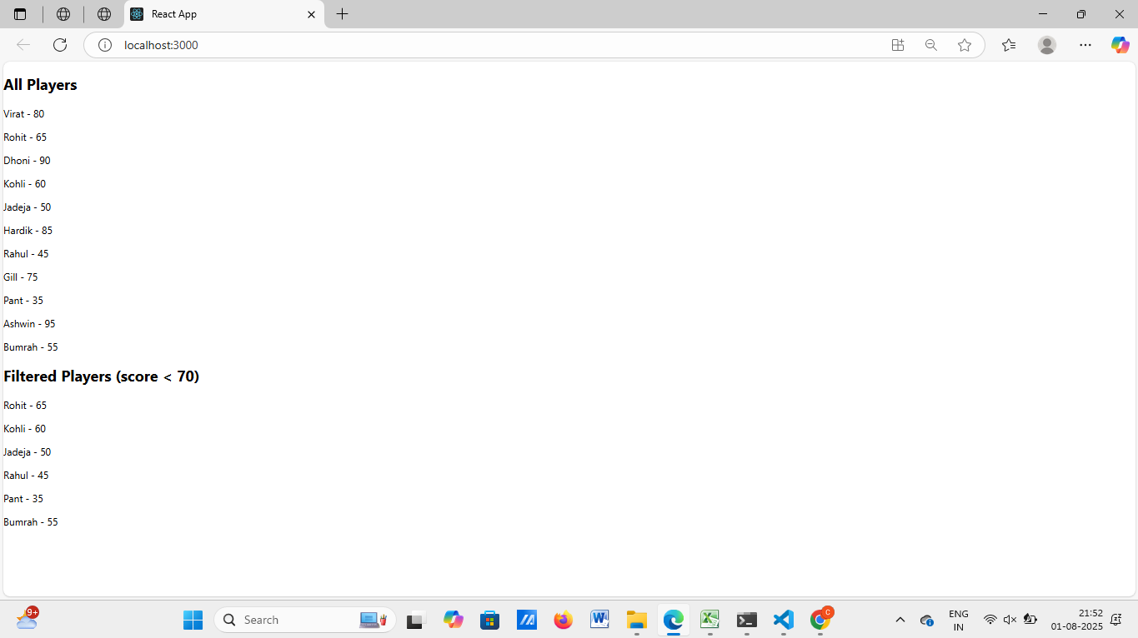

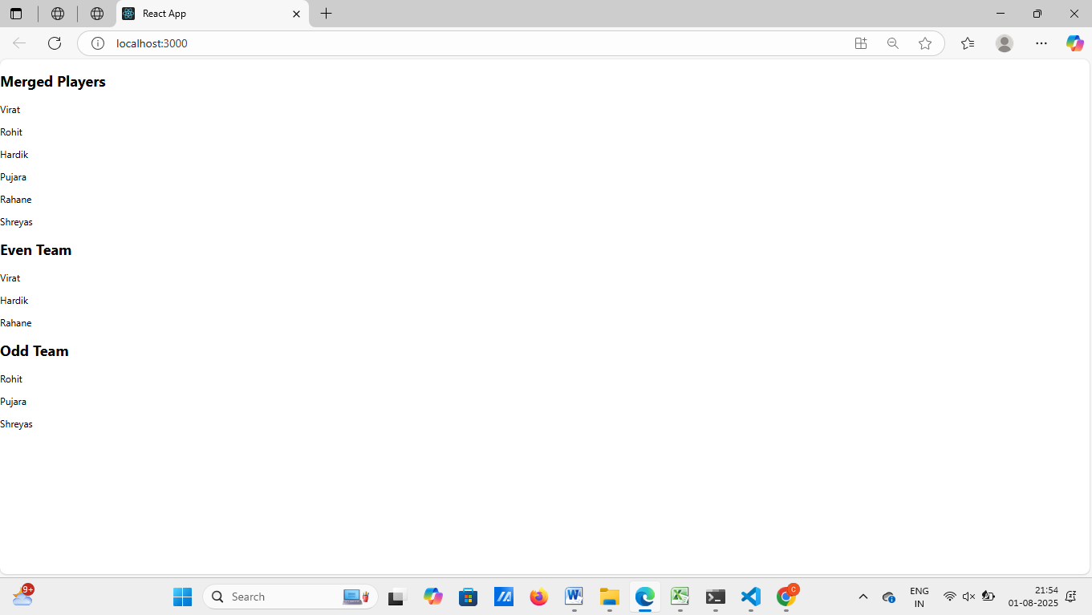

**Hands-on 2:**

Create a React Application named “officespacerentalapp” which uses React JSX to create elements, attributes and renders DOM to display the page.

**CODE:**

**App.js**

import React from 'react';

import './App.css';

const offices = [

  {

    name: "Tech Park",

    rent: 55000,

    address: "Coimbatore, Tamil Nadu",

    image: "https://via.placeholder.com/300x200?text=Tech+Park"

  },

  {

    name: "IT Hub",

    rent: 75000,

    address: "Chennai, Tamil Nadu",

    image: "https://via.placeholder.com/300x200?text=IT+Hub"

  },

  {

    name: "Business Center",

    rent: 45000,

    address: "Bangalore, Karnataka",

    image: "https://via.placeholder.com/300x200?text=Business+Center"

  }

];

function App() {

  return (

    <div className="App">

      <h1>🏢 Office Space Rental</h1>

      {offices.map((office, index) => (

        <div key={index} style={{ border: '1px solid grey', margin: '10px', padding: '10px' }}>

          <img src={office.image} alt={office.name} width="300" height="200" />

          <h2>{office.name}</h2>

          <p><strong>Address:</strong> {office.address}</p>

          <p style={{ color: office.rent > 60000 ? 'green' : 'red' }}>

            <strong>Rent:</strong> ₹{office.rent}

          </p>

        </div>

      ))}

    </div>

  );

}

export default App;

**OUTPUT:**

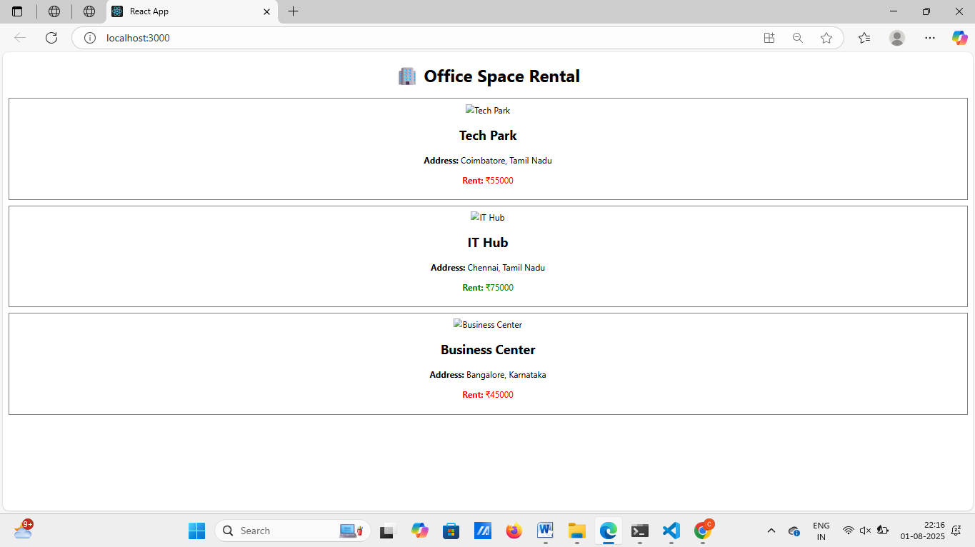

**Hands-on 3:**

Create a React Application “eventexamplesapp” to handle various events of the form elements in HTML.

**CODE:**

**CurrencyConverter.js**

import React, { useState } from 'react';

const CurrencyConvertor = () => {

const [rupees, setRupees] = useState('');

const [euro, setEuro] = useState('');

const handleSubmit = () => {

const rate = 0.011; // 1 INR = 0.011 EUR approx

setEuro((parseFloat(rupees) * rate).toFixed(2));

};

return (

<div>

<h2>Currency Convertor</h2>

<input

type="text"

placeholder="Enter INR"

value={rupees}

onChange={(e) => setRupees(e.target.value)}

/>

<button onClick={handleSubmit}>Convert</button>

<p>EUR: {euro}</p>

</div>

);

};

export default CurrencyConvertor;

**OUTPUT:**

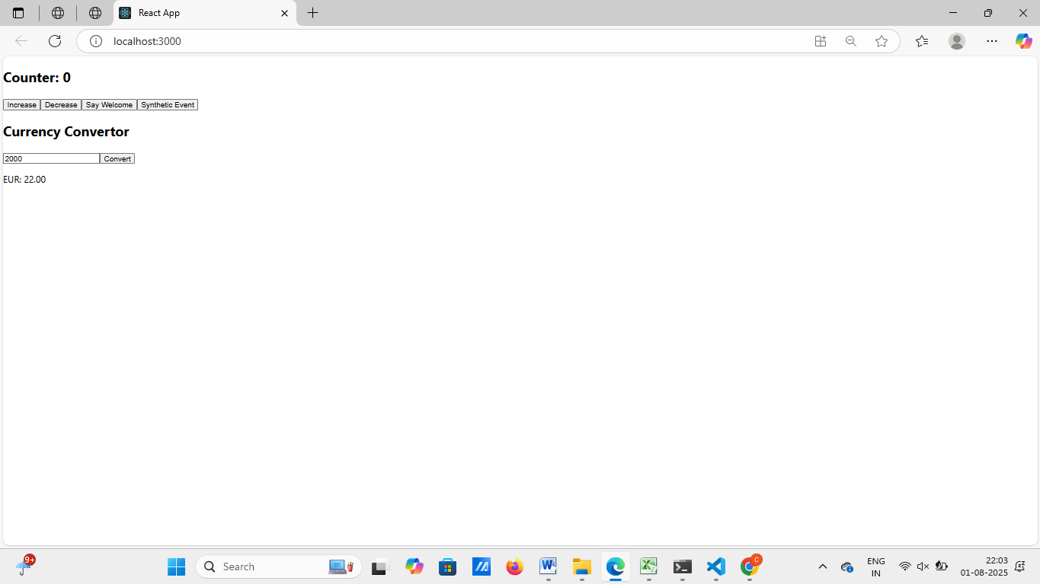

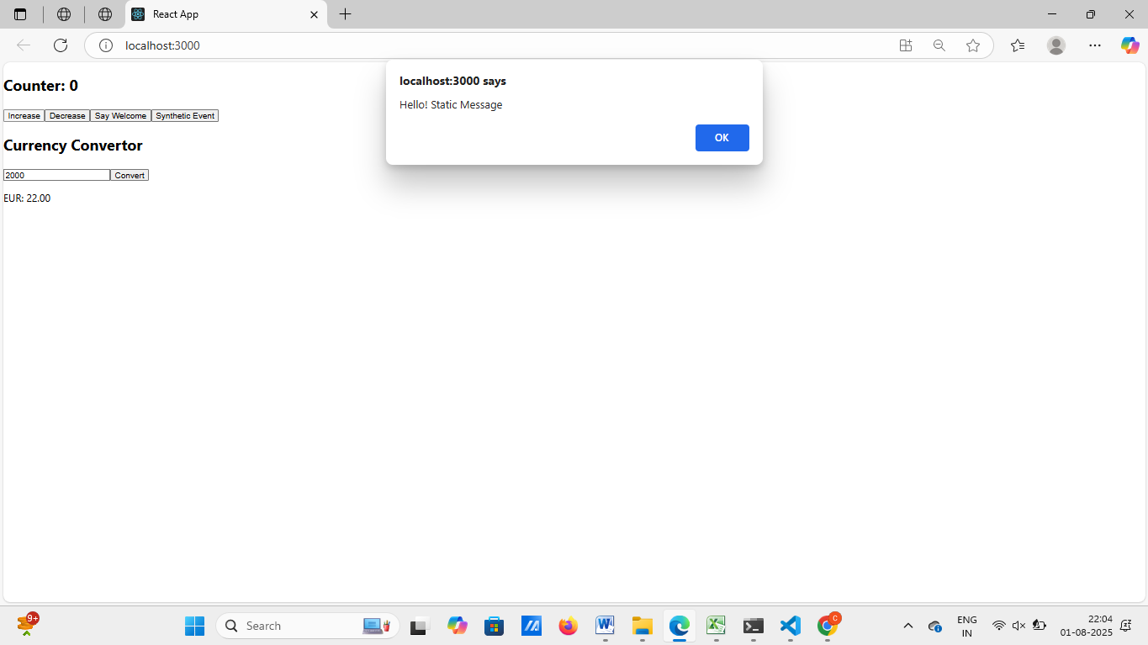

**Hands-on 4:**

Create a React App named “bloggerapp” in with 3 components.

1. Book Details
2. Blog Details
3. Course Details

**OUTPUT:**

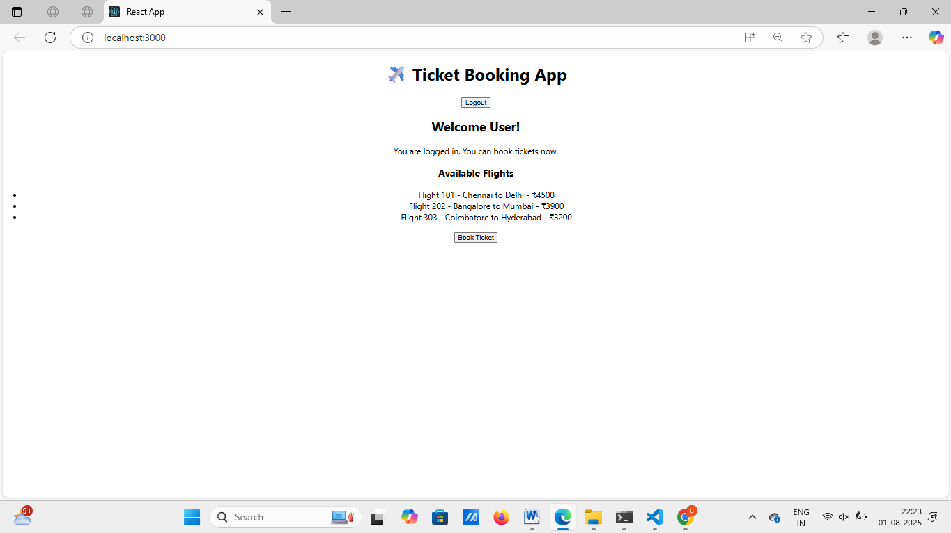

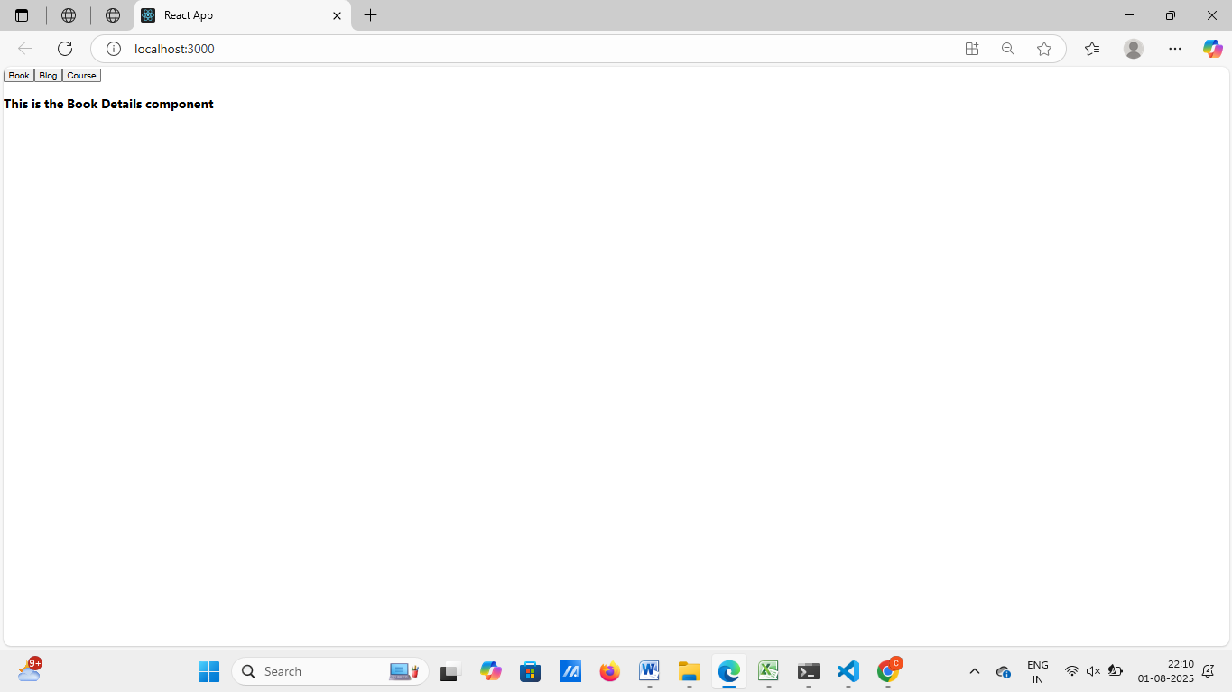

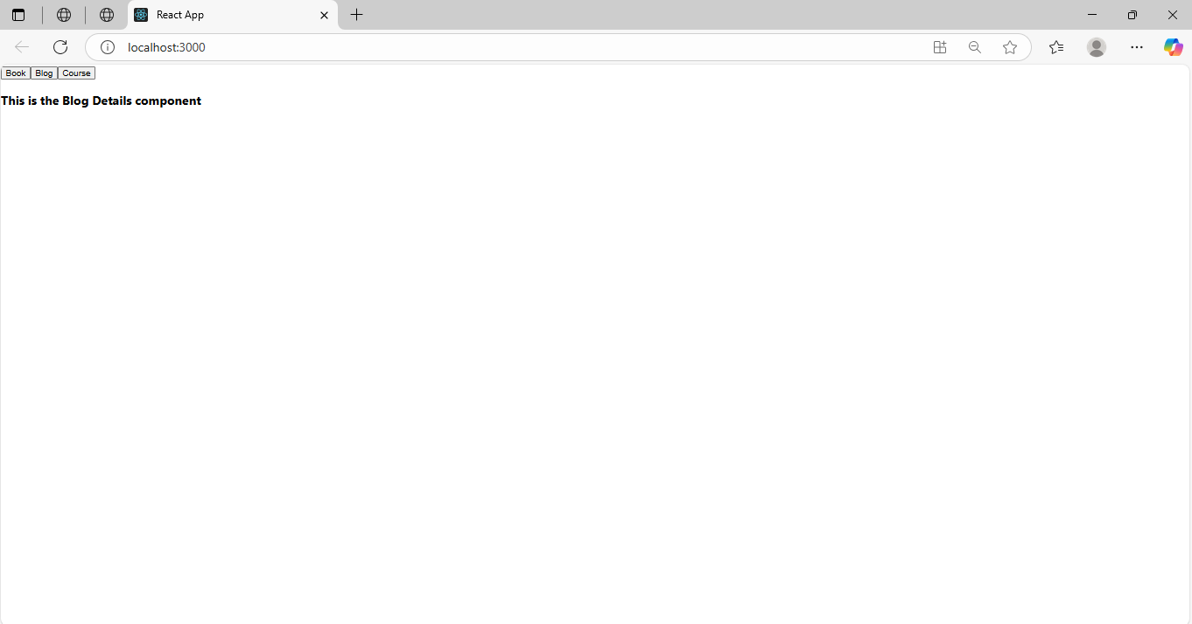

**Hands-on 5:**

Create a React App named “bloggerapp” in with 3 components.

1. Book Details
2. Blog Details
3. Course Details

**CODE:**

.

import React, { useState } from 'react';

import './App.css';

import BookDetails from './BookDetails';

import BlogDetails from './BlogDetails';

import CourseDetails from './CourseDetails';

function App() {

const [selected, setSelected] = useState('');

// Element variable method

let content;

if (selected === 'book') {

content = <BookDetails />;

} else if (selected === 'blog') {

content = <BlogDetails />;

} else if (selected === 'course') {

content = <CourseDetails />;

} else {

content = <p>Please select an option to view details.</p>;

}

return (

<div className="App">

<h1>📝 BloggerApp</h1>

<div>

<button onClick={() => setSelected('book')}>Show Book</button>

<button onClick={() => setSelected('blog')}>Show Blog</button>

<button onClick={() => setSelected('course')}>Show Course</button>

<button onClick={() => setSelected('')}>Clear</button>

</div>

<hr />

{/* 1. Using if-else with element variable */}

{content}

{/* 2. Using ternary operator */}

<div>

<h3>Using Ternary:</h3>

{selected === 'book' ? <BookDetails /> : null}

</div>

{/* 3. Using logical AND (&&) operator */}

<div>

<h3>Using && operator:</h3>

{selected === 'blog' && <BlogDetails />}

</div>

{/* 4. Using switch-case inside a function */}

<div>

<h3>Using switch-case:</h3>

{renderComponentBySwitch(selected)}

</div>

</div>

);

}

// Helper function: switch-case rendering

function renderComponentBySwitch(key) {

switch (key) {

case 'book':

return <BookDetails />;

case 'blog':

return <BlogDetails />;

case 'course':

return <CourseDetails />;

default:

return null;

}

}

export default App;

**OUTPUT:**

